Department of Computer Science and Engineering, University of Barishal
Theory of Computation (CSE-3203) — Mid-Term, 17 Sep 2025
Model Solutions | Total 40 Marks | 3rd Year 2nd Semester, Session 2020-21

Question Index by Topic
Q | Topic | Sub-topic | Marks
1 | Finite Automata | NFA design (first symbol reappears later) | 4
2 | NFA → DFA Conversion | (i) Worst case of subset construction (2ⁿ blow-up); (ii) pigeonhole principle | 8
3 | ε-NFA | ε-NFA design for {ε} ∪ Σ*01 | 4
4 | Regular Languages / ε-NFA | (i) Closure under adding a finite set; (ii) ε-NFA ≡ DFA | 8
5 | Regular Expressions & Automata | RE → ε-NFA (Thompson’s construction) | 4
6 | Mathematical Preliminaries (Proof Techniques) | (i) Direct proof / contradiction (mod); (ii) Mathematical induction | 8
7 | Introduction to Automata Theory | Importance and applications | 4

Notation. Σ = alphabet, here {0,1}; ε = empty string; δ = transition function; δ̂ = extended transition function; ECLOSE(q) = ε-closure of q (states reachable from q by ε-moves only).

Question 1 — NFA: the first symbol appears again later (4 marks)
Marks | 4
Topic | Finite Automata
Sub-topic | NFA design
Key technique | Remember the first symbol by branching, then guess a later occurrence

Language. Over Σ = {0,1}: L = { w | w = a·x·a·y, a ∈ Σ, x,y ∈ Σ* } = strings starting with 0 that contain another 0, or starting with 1 that contain another 1. (Examples: 010 ∈ L and 101 ∈ L; 011 ∉ L because it starts with 0 and has no later 0.)
Idea. The first symbol decides which branch to follow. In each branch the NFA loops on any symbol (state a or b) and, nondeterministically, guesses that the next symbol is the repeated one and moves to a final state, where the rest of the input is ignored.
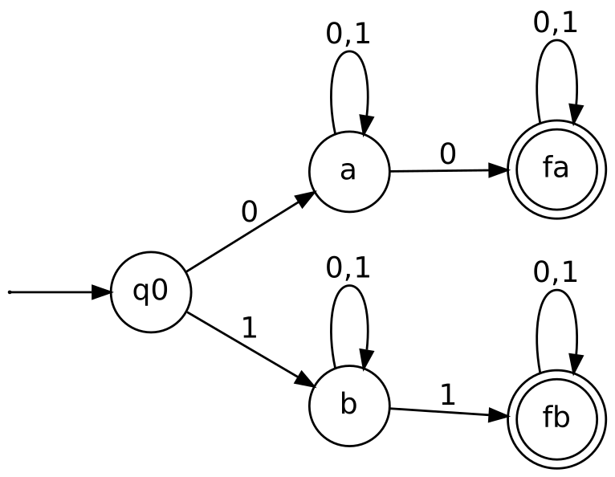
Figure 1: NFA for “first symbol occurs again later”
Formal definition. N = (Q, {0,1}, δ, q₀, F) with Q = {q₀, a, b, fa, fb}, F = {fa, fb}.
State | On 0 | On 1
→ q₀ | {a} | {b}
a | {a, fa} | {a}
b | {b} | {b, fb}
* fa | {fa} | {fa}
* fb | {fb} | {fb}

Check. 0110: q₀ —0→ a —1→ a —1→ a —0→ fa (accept). 011: q₀ —0→ a —1→ a —1→ a (no accepting path, reject). 1001: q₀ —1→ b —0→ b —0→ b —1→ fb (accept).

Question 2 — Bad case of subset construction; pigeonhole principle (8 marks)
Marks | 8
Topic | NFA → DFA conversion
Sub-topic | (i) Worst-case state blow-up of the subset construction; (ii) pigeonhole principle
Key technique | Distinguishability argument

(The question says “DFA to NFA”; the subset construction converts an NFA to a DFA, which is what is analysed below.)

(i) The “bad case” for the subset construction
Upper bound. If an NFA N has n states, the subset construction produces a DFA whose states are subsets of Q, so at most 2ⁿ states. The bad case is when this bound is actually reached, i.e. the smallest DFA really needs 2ⁿ states.
The classic bad-case language. Lₙ = { w ∈ {0,1}* : the n-th symbol from the right end of w is 1 }. It is accepted by an NFA with only n+1 states: q₀ loops on 0,1; q₀ —1→ q₁; then qᵢ —0,1→ qᵢ₊₁ for i = 1…n−1; qₙ is final. The NFA guesses the position of the n-th symbol from the end. Figure 2 shows n = 3 (4 states).
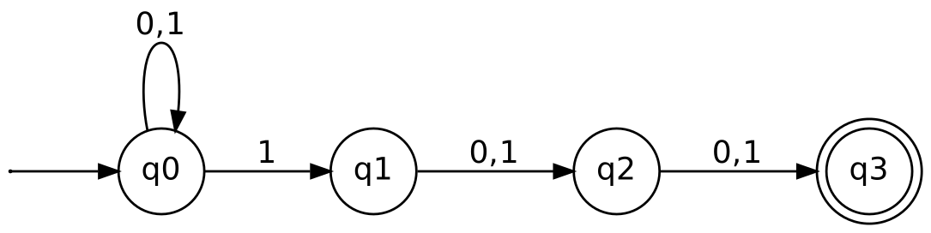
Figure 2: NFA for L₃ — third symbol from the end is 1 (4 states)
Why the DFA is large. A DFA reading left to right must remember the last n symbols, because any of them may become the n-th from the end later. There are 2ⁿ possible last-n-symbol windows, so the DFA needs 2ⁿ states. In the subset construction the reachable subsets are {q₀} ∪ {qᵢ+1 : the symbol i places back from the end is 1}, giving 2ⁿ different subsets. For n = 3: NFA has 4 states but the minimal DFA has 8; for n = 20 an NFA with 21 states needs over a million DFA states.
Formal lower-bound proof. Suppose a DFA D for Lₙ has fewer than 2ⁿ states. There are 2ⁿ strings of length n, so (pigeonhole, part ii) two different strings x ≠ y of length n reach the same state. Let i be the first position where they differ, say xᵢ = 1, yᵢ = 0. Append z = 0ⁱ⁻¹. Then xz and yz have length n+i−1, and their n-th symbols from the end are xᵢ = 1 and yᵢ = 0 respectively, so xz ∈ Lₙ and yz ∉ Lₙ. But δ̂(q₀,xz) = δ̂(q₀,yz) since x and y reach the same state: a contradiction. Hence every DFA for Lₙ has ≥ 2ⁿ states.
Conclusion. The exponential blow-up is unavoidable in the worst case. In practice many subsets are unreachable, so the lazy form of the construction (generate only subsets reachable from {q₀}) often yields far fewer states.

(ii) The pigeonhole principle
Statement. If m objects (pigeons) are placed into n boxes (holes) and m > n, then at least one box contains at least two objects. More generally, some box holds at least ⌈m/n⌉ objects.
Proof (contradiction). If every box held at most one object, the total would be ≤ n < m, contradicting that m objects were placed.
Role in the subset construction. Treat the 2ⁿ strings of length n as pigeons and the states of a DFA with fewer than 2ⁿ states as holes. Two distinct strings must end in the same state, so the DFA cannot tell them apart (it must treat them identically for every continuation). If some continuation z separates them (xz ∈ L, yz ∉ L), a contradiction follows, as in part (i). Thus the principle shows that a DFA needs at least as many states as there are pairwise distinguishable strings. The same idea (a repeated state among n+1 visited states) underlies the pumping lemma.

Question 3 — ε-NFA for L = { w | w is empty, or ends in 01 } (4 marks)
Marks | 4
Topic | ε-NFA
Sub-topic | ε-NFA design
Key technique | L = {ε} ∪ Σ*01 built with two ε-branches

Analysis. L = {ε} ∪ (0+1)*01 over Σ = {0,1}. Use two parallel branches from the start state q₀ joined by ε-moves.
- Empty string: q₀ —ε→ q₃ (final).
- Ends in 01: q₀ —ε→ q₁; q₁ loops on 0,1; q₁ —0→ q₂ —1→ q₃.
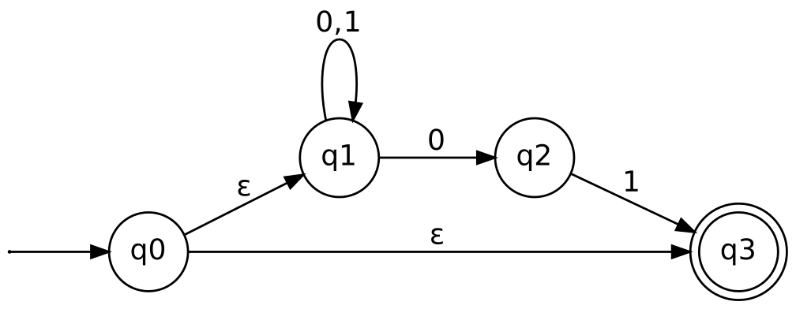
Figure 3: ε-NFA for {ε} ∪ Σ*01
Formal definition. N = ({q₀,q₁,q₂,q₃}, {0,1}, δ, q₀, {q₃}):
State | 0 | 1 | ε
→ q₀ | ∅ | ∅ | {q₁, q₃}
q₁ | {q₁, q₂} | {q₁} | ∅
q₂ | ∅ | {q₃} | ∅
* q₃ | ∅ | ∅ | ∅

Check. ε: q₀ →ε q₃ (accept). 1101: q₀ →ε q₁, loop on 1,1, 0 to q₂, 1 to q₃ (accept). 10: ends in q₁ or q₂ (reject). So L(N) = {ε} ∪ Σ*01.

Question 4 — Finite additions; ε-NFA ≡ DFA (8 marks)
Marks | 8
Topic | Regular Languages and ε-NFA
Sub-topic | (i) Closure of regular languages under union with a finite set; (ii) equivalence of ε-NFA and DFA
Key technique | Union closure; ε-closure and subset construction with induction

(i) Adding a finite set of strings to a regular language
Claim. If L is regular and F is a finite set of strings, then L ∪ F is regular.
Proof. Step 1 — every finite language is regular. A single string w = a₁a₂…aₖ is described by the regular expression a₁a₂…aₖ (and ε by ε). If F = {w₁, …, wₘ}, then F is described by the regular expression w₁ + w₂ + … + wₘ (and the empty set by ∅). Hence F is regular.
Step 2 — L is regular, so L = L(R) for some regular expression R; and F = L(R_F) by Step 1. Then
L ∪ F = L(R) ∪ L(R_F) = L(R + R_F),
which is a regular expression. Therefore L ∪ F is regular. ∎
Automaton view. Equivalently, build an ε-NFA for each wᵢ (a chain of |wᵢ| edges) and for L, then use the union construction: a new start state with ε-moves to every machine and a new final state reached by ε-moves from each machine’s final state.
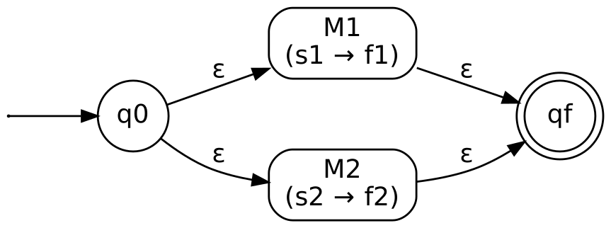
Figure 4: Union construction used to add finite strings to L

(ii) A language is accepted by an ε-NFA iff it is accepted by a DFA
Theorem. L is accepted by some ε-NFA ⇔ L is accepted by some DFA.
(⇐) Every DFA is an ε-NFA that has no ε-transitions (replace δ(q,a) = p by δ(q,a) = {p}). So any DFA language is accepted by an ε-NFA.
(⇒) Let E = (Q_E, Σ, δ_E, q₀, F_E) be an ε-NFA. Define the DFA D = (Q_D, Σ, δ_D, q_D, F_D) by
- Q_D = 2^{Q_E} (sets of states of E);
- q_D = ECLOSE(q₀);
- F_D = { S ∈ Q_D : S ∩ F_E ≠ ∅ };
- δ_D(S, a) = ECLOSE( ⋃_{p ∈ S} δ_E(p, a) ) for every S ∈ Q_D, a ∈ Σ.
Claim. δ̂_D(q_D, w) = δ̂_E(q₀, w) for every w ∈ Σ*. Proof by induction on |w|.
- Basis (w = ε): δ̂_E(q₀, ε) = ECLOSE(q₀) = q_D = δ̂_D(q_D, ε).
- Step (w = xa): Let S = δ̂_E(q₀, x). By the inductive hypothesis S = δ̂_D(q_D, x). By definition of δ̂_E, δ̂_E(q₀, xa) = ECLOSE( ⋃_{p ∈ S} δ_E(p, a) ) = δ_D(S, a) = δ̂_D(q_D, xa).
Hence w ∈ L(D) ⇔ δ̂_D(q_D,w) ∈ F_D ⇔ δ̂_E(q₀,w) ∩ F_E ≠ ∅ ⇔ w ∈ L(E). So L(D) = L(E), and every ε-NFA language is accepted by a DFA. ∎

Question 5 — RE to ε-NFA: (0+1)*01(0+1)* (4 marks)
Marks | 4
Topic | Regular Expressions & Automata
Sub-topic | RE → ε-NFA conversion
Key technique | Thompson’s construction

Decomposition. R = A · 0 · 1 · A where A = (0+1)*. Build the machine for 0+1 (union), apply star (add ε-loop and ε-skip), then concatenate with machines for 0, 1 and a second copy of A using ε-links.
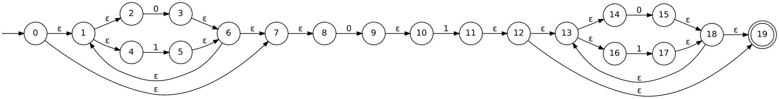
Figure 5: ε-NFA for (0+1)*01(0+1)* (start = 0, final = 19)
Structure. States 0–7: first (0+1)*; states 8–11: the symbols 0 and 1; states 12–19: second (0+1)*. Check with 1001: the first loop consumes “10”, states 8–11 match “01”, and the second loop (or its ε-skip) reaches 19, so 1001 is accepted. The string 110 contains no “01”, so it is rejected.

Question 6 — Proof techniques (8 marks)
Marks | 8
Topic | Mathematical Preliminaries (Proof Techniques)
Sub-topic | (i) Proof by contradiction/cases (modular arithmetic); (ii) Proof by induction
Key technique | Contradiction and simple induction

(i) a mod b = b mod a ⇔ a = b (a, b positive integers)
(⇐) If a = b then a mod b = b mod a trivially (both sides are the same expression).
(⇒) by contradiction. Suppose a mod b = b mod a but a ≠ b. Without loss of generality a < b (the statement is symmetric).
- Since 0 < a < b, a mod b = a (the quotient is 0).
- b mod a is a remainder on division by a, so 0 ≤ b mod a ≤ a − 1 < a.
Then a = a mod b = b mod a < a, i.e. a < a, a contradiction. Hence a = b. ∎

(ii) If x ≥ 4 then 2ˣ ≥ x² (induction on integers x ≥ 4)
Basis (x = 4): 2⁴ = 16 and 4² = 16, so 2⁴ ≥ 4².
Inductive hypothesis: Assume 2ᵏ ≥ k² for some k ≥ 4.
Inductive step: Show 2ᵏ⁺¹ ≥ (k+1)².
2ᵏ⁺¹ = 2·2ᵏ ≥ 2k² (by the hypothesis)
It remains to show 2k² ≥ (k+1)² = k² + 2k + 1, i.e. k² − 2k − 1 ≥ 0, i.e. (k−1)² ≥ 2. For k ≥ 4, (k−1)² ≥ 9 ≥ 2, so this holds. Therefore 2ᵏ⁺¹ ≥ (k+1)².
By the principle of mathematical induction, 2ˣ ≥ x² for all integers x ≥ 4. ∎

Question 7 — Importance of Automata Theory (4 marks)
Marks | 4
Topic | Introduction to Automata Theory
Sub-topic | Importance and applications
Key technique | Descriptive answer

Automata theory studies abstract machines (finite automata, pushdown automata, Turing machines) and the languages they recognise. Its importance:
- Foundation of computer science: it defines what “computation” means and classifies problems by the power of machines (the Chomsky hierarchy: regular, context-free, context-sensitive, recursively enumerable).
- Compiler design: lexical analysis uses regular expressions and finite automata; parsing uses context-free grammars and pushdown automata.
- Pattern matching and text processing: grep, regex engines, search tools, spell checkers and input validation are implemented with finite automata.
- Hardware and software modelling: digital circuits, protocol design, controllers, vending machines and UI/game logic are modelled as finite-state machines; model checking verifies them.
- Natural language and AI: grammars and automata are used in parsing, speech recognition and bioinformatics sequence analysis.
- Limits of computation: it identifies problems that no machine can solve (undecidability) and those that are intractable, guiding realistic algorithm design.
- Proof and reasoning skills: it trains rigorous techniques such as induction, contradiction, pigeonhole and closure arguments.

